The Macmillan English Campus

One problem facing technological developers in the creation of learning platforms is: “if we build it, will they come?” In 2002, the Cultura Inglesa chain of language schools in Brazil took the unprecedented step of commissioning a suite of web-based materials from a UK publisher, Macmillan, ostensibly for use in self-study. Macmillan developed the Campus. The possibilities of exploiting the e-Campus in the classroom were explored. The chain school increased their course prices to cover development costs. The e-Campus proved a commercial success, in that student numbers increased due to the “added value” of the technology component. It also had a degree of pedagogical success, in that teachers began to use the Campus within the language classroom.

What is it?

“MEC is an Internet-based, interactive learning environment that helps (….) learners to practise English” (Training Manual)

“It contains a (….) database of over 1,500 highly interactive activities, tests, games and grammar reference units” (Publicity material)

Features

The Macmillan English Campus contains the following features:

- An online English language database resource of around 2,000 interactive activities covering grammar, vocabulary, listening and pronunciation practice, including business English
- Six levels, with up to 100 hours of practice material at each level
- Progress tests and Cambridge ESOL exam preparation exercises, including PET and IELTS
- A selection of interactive and animated language learning games at three ability levels focusing on different elements of English practice
- Access to a range of reference materials including the Macmillan English Learner’s Dictionary Online, a comprehensive grammar reference database and a methodology database for teachers only
- Six pre-set practice courses from beginner to advanced level, created from the content database and structured into paths of study
- Course building tools to allow institutions to pick resources and activities from the database to suit specific class needs, effectively allowing teachers to put together a supplementary program tailored to specific syllabus requirements.
- Weekly news articles taken from the International Guardian newspaper edited to three levels of language competence
- A Markbook feature which automatically records the results of activities completed allowing both students and teachers to track and monitor progress, and print or download results.

The Macmillan English Campus provides students with a supplementary practice tool to improve their English. The availability of the six core practice courses enables the client to choose whether to use these courses, or to create their own using the course building tools, to supplement their existing English programmes. If required, this facility could enable teachers and coursebuilders to construct a wholly online programme, thus eliminating the need for course books and/ or workbooks, as long as face to face or other teacher-led guidance was incorporated.
Teachers can: use Macmillan English Campus in the classroom (with a data projector) or in the computer language lab / access student records and marks at home.

Students can: work on Macmillan English Campus lessons in the classroom or computer language lab, guided by the teacher / work on their own at home, in an internet cafe or in their workplace, and see the results of their work immediately

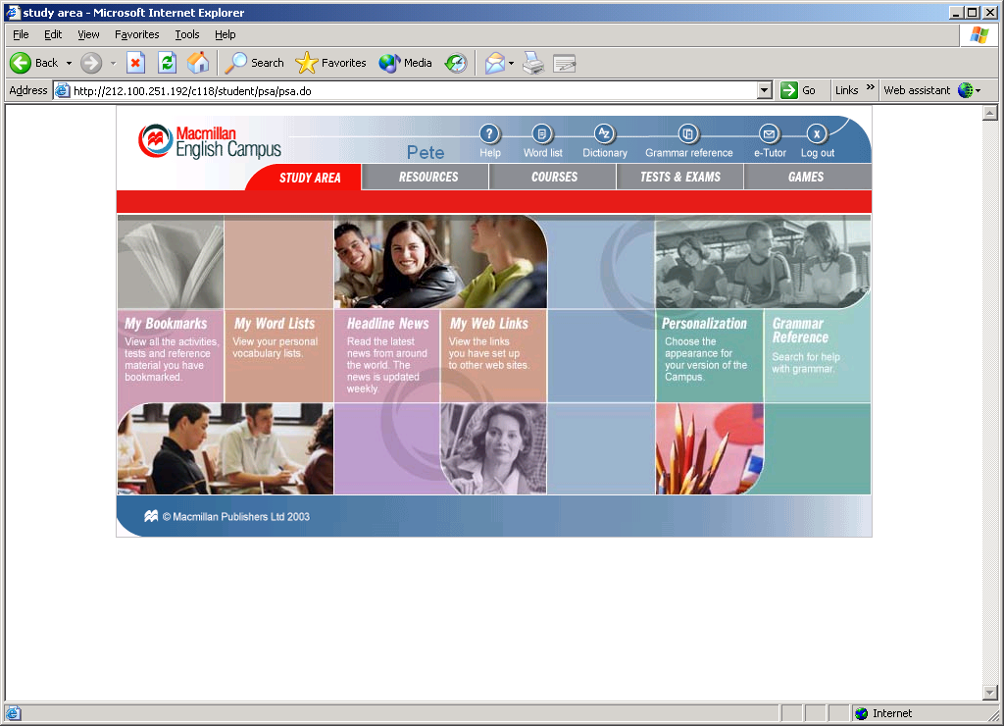

Macmillan English Campus Content

Every exercise and activity in the resource database exploits the interactive potential of the online medium. The main forms of interactivity are:

- Gap fill – typing a word or words in a designated field
- Drag and drop – moving a word or phrase from a menu to its correct position
- Multiple choice – clicking on a word, phrase or sentence chosen from a selection
- Match lists – linking related words or phrases
- Rearrange – dragging words, phrases or sentences into their correct arrangement
- Word select – highlighting or deleting words in a body of text
- True/false – clicking on true/false to choose a correct answer
- Checklist – clicking on multiple correct answers

MEC content includes:

Language exercises
Language exercises comprise both grammar and function activities. At lower language levels, they focus on specific objectives, allowing the student to concentrate on one area of English at a time

Pronunciation activities
These activities offer students pronunciation practice covering sounds, stress, intonation and word linking. They provide opportunities for discrimination and for repetition and allow students to become familiar with different registers and the sound of different types of English.

Vocabulary activities
These activities focus on extending students' range of vocabulary, for example of phrasal verbs, synonyms, prefixes and suffixes and lexical sets.

Progress tests
These are pre-prepared tests each containing three exercises – grammar, vocabulary and listening. Each test begins with advice to the student and suggestions for revision before undertaking the test.

Exam preparation exercises
These exercises are developed in the style of the Cambridge ESOL examination for which students are studying for.

Practical teaching ideas for using MEC in the classroom

1. Use the bookmark feature

Bookmark a sequence of activities: the teacher can use the bookmark feature to develop an integrated skills lesson, saving (for example) a sequence of activities, which they could re-use in different lessons

2. Use the animations

Present a language structure using an animation from a Grammar reference unit

3.Exploit the Headline News

Macmillan English Campus provides a range of international news articles as additional reading material for students. Each news article is available in three bands of language ability. These articles are updated on a weekly basis, and all users of the English Campus are able to access an archive of previous news items. The news articles offer valuable extra reading practice for students. e.g. students read the ‘easy’ level first to get a summary of the text; read the ‘average or difficult’ level, with the MEDO open.

4.Mask part of the screen.

In the language exercises in the Macmillan English Campus, part of the text can be “hidden”. This can be used to great effect in a lesson. It is possible for instance to only reveal a set of answers. The students then work in groups to construct the appropriate questions, providing practice in the tricky language area of question formation.

5. Have students prepare a classroom talk / presentation with the MEDO

Students often give a mini-talk as part of their fluency practice. The teacher negotiates suitable topics first. As part of their preparation, students can check the pronunciation of words using a CD-ROM English-English dictionary from any of the major publishers.

MEC can also be used to encourage learner independence / student autonomy

6. Building an electronic wordlist

Encourage students to organise lists with categories. Students can put words into more than one category, invent a pronunciation notation and include pronunciation details in the entry
- Encourage a systematic approach to listening

The campus offers many opportunities for listening. Students can gain exposure to normal speed speech and can pause at will; they have the choice to listen and read simultaneously, as they can access a transcript. Listening activities offer clear audio recordings that last up to three minutes.

8. Use the web projects

These can be a first step into a huge learning resource - the World Wide Web; do these in small teams and make them last over several lessons. Regard the MEC project material as only a springboard to more detailed research and more productive activities related to the theme. Get learners to make their own web projects to set as tasks for their peers

9 Use the markbook

Use the markbook as a motivational as well as administrative tool. Show the class overview page to the whole class regularly to show them their progress (cover names with another document if necessary). Have at least three in class views of the markbook early on in the course. Show learners how an organised approach to MEC can be ‘seen’ in the markbook
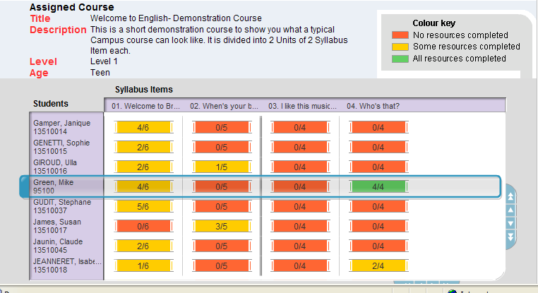

10 Exploit the games

Games are an important part of the learning platform, offering a vivid, highly interactive and motivational resource for students of any age and level. There are three types of game available in three bands of language ability.

Word games - the Word games take the form of crossword puzzles, word searches etc. The vocabulary in the Word Games is updated automatically by Macmillan every month.

Games Gallery - Games in this section are single screen, highly interactive grammar or vocabulary-building games aimed at reinforcing one particular grammar point or set of vocabulary.

Multi-level games - The Macmillan English Campus contains adventure games covering a number of language topics. These games require several hours to complete. They are based on an adventure/quest model and require the student to complete contextualized language tasks in order to proceed.



Business English content

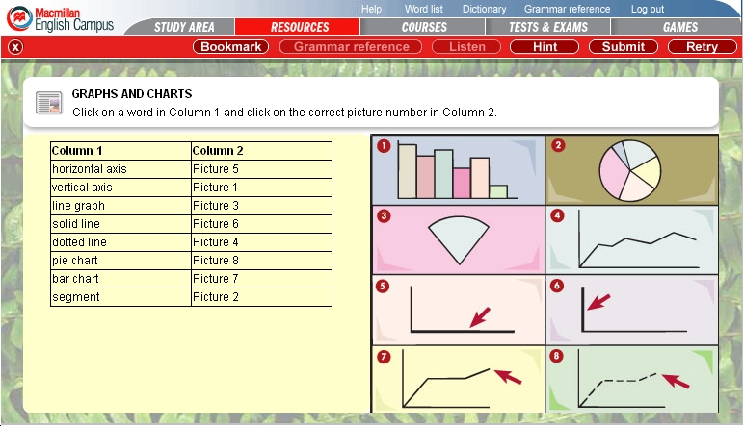

Earlier this year, in May, Macmillan made two hundred new Business English resources available on their English Campus. This more than doubles the amount of Business English material available to users.

Bio spec

Pete Sharma is a lecturer, author and teacher trainer. Pete reviews software, and has written books on technology in language teaching. He writes a weekly business English e-lesson for Macmillan. His Masters dissertation evaluated the Macmillan English Campus. His next book (2007) as co-author is on Blended Learning. Visit: www.te4be.com

For more on the Campus, please visit: http://www.macmillanenglishcampus.com/

